

**Polling District and Polling Place Review 2025**

**Wingrove Ward**

**Parliamentary Constituency:** Central and West

**(Proposed) Polling Districts:** Z01, Z02, Z03, Z04, Z05, Z06

The Local Government Boundary Commission for England are an independent body accountable to Parliament. They are responsible for reviewing councils to make sure their patterns of internal wards are fair and sensible. Their reviews include at least two rounds of public consultation before they make recommendations for change.

The final recommendations were published on 7 January 2025, and the new arrangements apply to local elections from 2026.

As a result of changes to ward boundaries the Acting Returning Officer (ARO) is conducting a review of polling districts and polling places to ensure that they are suitable for the new ward boundaries.

For more information on the local government boundary review visit: <https://www.lgbce.org.uk/all-reviews/newcastle-upon-tyne>

This document provides details of the review, along with the initial recommendations and comments of the Acting Returning Officer (ARO). Also, the election rules require the ARO to decide how many polling stations are required for each polling station and the ARO must allocate electors to the polling stations in such manner as they think most convenient.

These recommendations will be open to all residents, stakeholders, and any interested parties. We shall be seeking representations from local disability groups on the accessibility and suitability of polling places. Any comments should be addressed in the first instance to pollingplaces@newcastle.gov.uk where they will be collated on behalf of the (Acting) Returning Officer.

We considered the following factors:

* **Identifying new polling places:** We will look for new polling places in areas where the existing provision is unsuitable or unavailable.
* **Feedback:** We will consider feedback received following recent elections, consultation from members of the public, elected members, and other stakeholders.
* **Accessibility:** We will try to ensure that every polling place is accessible to electors with disabilities.
* **Facilities**: We will make sure that all electors have such reasonable facilities for voting as are practicable in the circumstances.
* **Elector numbers:** We will try to comply with the Electoral Commission guidance on the maximum number of electors that should be allocated to a polling station which should not exceed 2,250.
* **Future housing developments**: We will consider the impact of proposed housing developments on polling station electorates.

**(Current) Wingrove Ward**

This map shows the current ward and polling district boundaries and the polling places.

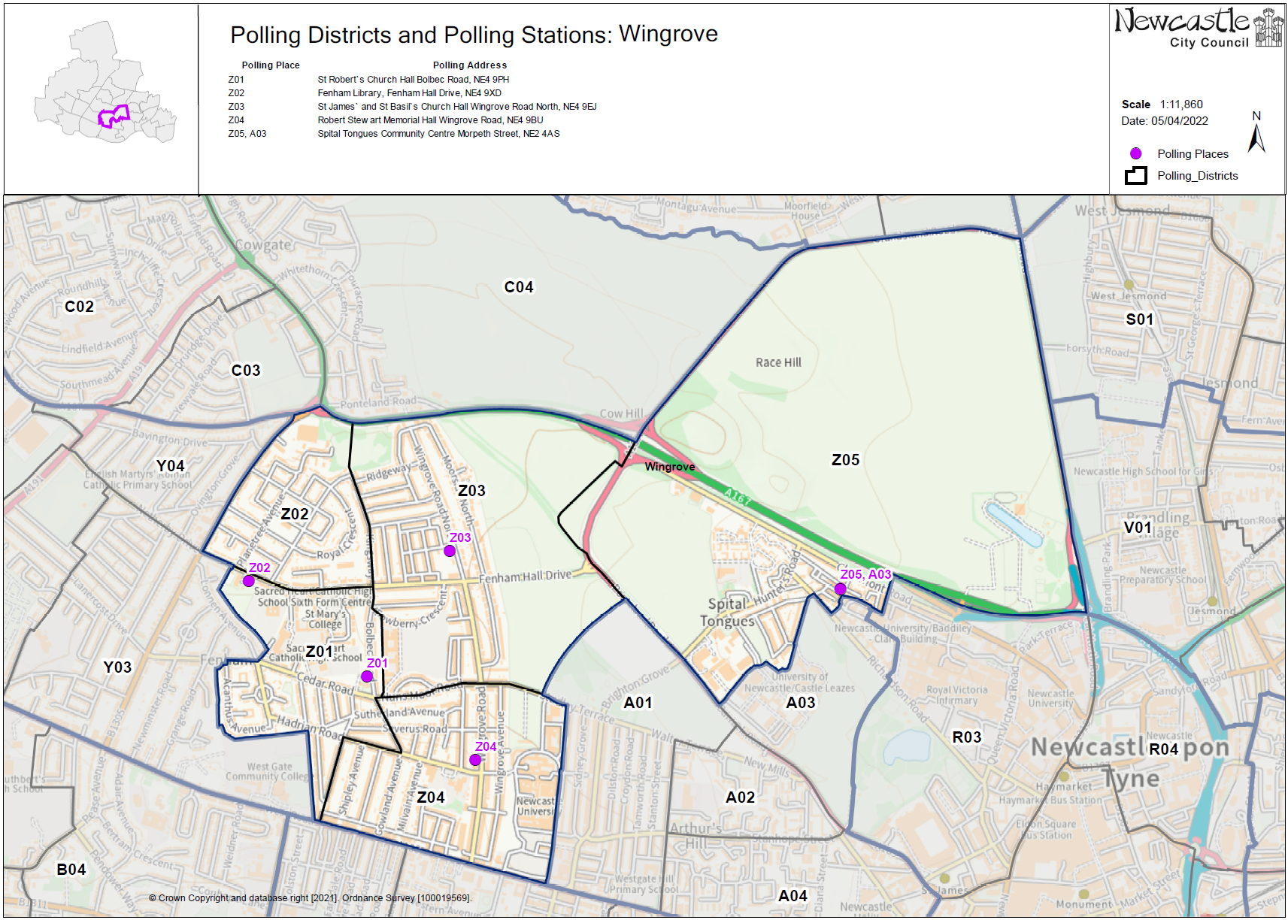

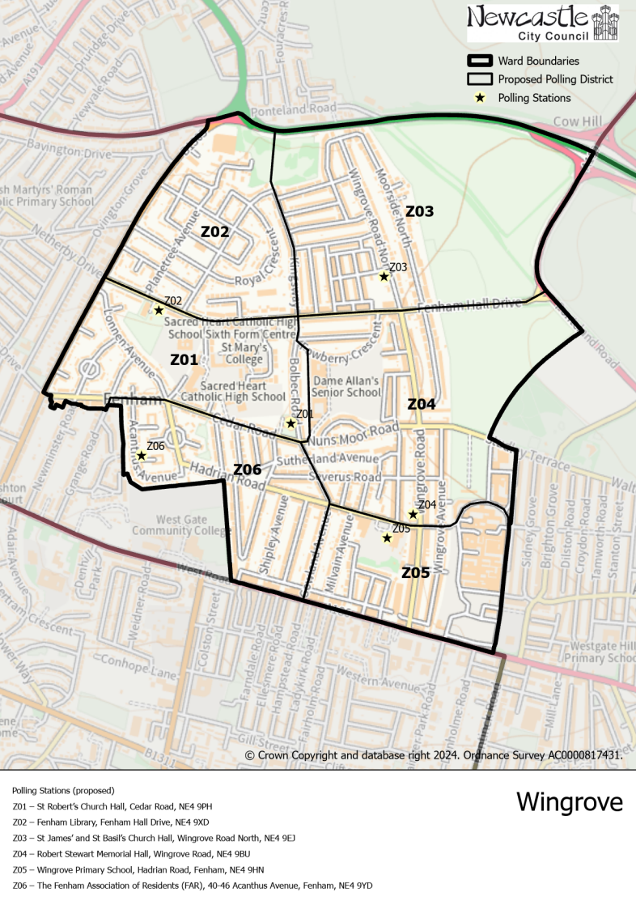**(New)**

**Wingrove Ward**

This map shows the new ward and the proposed polling districts and the proposed polling places.

* **Z01**

St Robert’s Church Hall, Cedar Road, NE4 9PH

* **Z02**

Fenham Library, Fenham Hall Drive, NE4 9XD

* **Z03**

St James’ and St Basil’s Church Hall, Wingrove Road North, NE4 9EJ

* **Z04**

Robert Stewart Memorial Hall, Wingrove Road, NE4 9BU

* **Z05**

Wingrove Primary School, Hadrian Road, Fenham, NE4 9HN

* **Z06**

The Fenham Association of Residents (FAR), 40-46 Acanthus Avenue, Fenham, NE4 9YD

**Wingrove Ward**

**Polling District Z01**

|  |
| --- |
| **Considerations and Proposals** |
| Parts of current Z01 and current Y03 would merge to create the proposed Z01 district. Properties to the east of Two Ball Lonnen move into the proposed Z01 district.  St Robert’s Church Hall is the recommended polling place to serve the electors in the proposed Z01 district. |

|  |  |
| --- | --- |
| **Current Polling District** | **Current Polling Place** |
| Z01* (part of)  Y03* (part of) | St Robert`s Church Hall, Cedar Road, NE4 9PH  West End URC Hall, Lanercost Drive, NE5 2DE |

|  |  |  |
| --- | --- | --- |
| **Proposed Polling District** | **Predicted**  **Polling Station Electorate** | **Proposed Polling Place** |
| Z01 | 566 | St Robert’s Church Hall, Cedar Road, NE4 9PH |

|  |
| --- |
| **Preliminary Consultation – Elected Members comments and feedback** |
| No comments received. |

**Wingrove Ward**

**Polling District Z02**

|  |  |
| --- | --- |
| **Current Polling District** | **Current Polling Place** |
| Z02 (full) | Fenham Library, Fenham Hall Drive, NE4 9XD |

|  |  |  |
| --- | --- | --- |
| **Proposed Polling District** | **Predicted**  **Polling Station Electorate** | **Proposed Polling Place** |
| Z02 | 761 | Fenham Library, Fenham Hall Drive, NE4 9XD |

|  |
| --- |
| **Considerations and Proposals** |
| No changes to the polling district.  No change to the polling place. |

|  |
| --- |
| **Preliminary Consultation – Elected Members comments and feedback** |
| No comments received. |

**Wingrove Ward**

**Polling District Z03**

|  |  |
| --- | --- |
| **Current Polling District** | **Current Polling Place** |
| Z03* (part of)  Z05* (part of) | St James` and St Basil`s Church Hall, Wingrove Road North, NE4 9EJ  Spital Tongues Community Centre, Morpeth Street, NE2 4AS |

|  |  |  |
| --- | --- | --- |
| **Proposed Polling District** | **Predicted**  **Polling Station Electorate** | **Proposed Polling Place** |
| Z03 | 879 | St James and St Basil’s Church Hall, Wingrove Road North, NE4 9EJ |

|  |
| --- |
| **Considerations and Proposals** |
| Part of current Z03 and a non-residential part of current Z05 would merge to create the proposed Z03 district. The proposed Z03 district would incorporate properties to the north of Fenham Hall Drive.  No change to the polling place. |

|  |
| --- |
| **Preliminary Consultation – Elected Members comments and feedback** |
| No comments received. |

**Wingrove Ward**

**Polling District Z04**

|  |  |
| --- | --- |
| **Current Polling District** | **Current Polling Place** |
| Z03* (part of)  Z04* (part of) | St James` and St Basil`s Church Hall, Wingrove Road North, NE4 9EJ  Robert Stewart Memorial Hall, Wingrove Road, Newcastle upon Tyne, NE4 9BU |

|  |  |  |
| --- | --- | --- |
| **Proposed Polling District** | **Predicted**  **Polling Station Electorate** | **Proposed Polling Place** |
| Z04 | 1184 | Robert Stewart Memorial Hall, Wingrove Road, NE4 9BU |

|  |
| --- |
| **Considerations and Proposals** |
| Part of current Z03 and part of current Z04 would merge to create the proposed Z04 district. The proposed Z04 district incorporates properties south of Fenham Hall Drive and north of Hadrian Road.  Robert Stewart Memorial Hall is well located within the proposed Z04 district. |

|  |
| --- |
| **Preliminary Consultation – Elected Members comments and feedback** |
| No comments received. |

**Wingrove Ward**

**Polling District Z05**

|  |  |
| --- | --- |
| **Current Polling District** | **Current Polling Place** |
| Z04* (part of) | Robert Stewart Memorial Hall |

|  |  |  |
| --- | --- | --- |
| **Proposed Polling District** | **Predicted**  **Polling Station Electorate** | **Proposed Polling Place** |
| Z05 | 699 | Wingrove Primary School, Hadrian Road, Fenham, NE4 9HN |

|  |
| --- |
| **Considerations and Proposals** |
| Part of current Z04, south of Hadrian Road and west as far as Gowland Avenue would create the proposed Z05 polling district.  Wingrove Primary School is the suggested polling station for this district. Site visit is required. |

|  |
| --- |
| **Preliminary Consultation – Elected Members comments and feedback** |
| No comments received. |

**Wingrove Ward**

**Polling District Z06**

|  |  |
| --- | --- |
| **Current Polling District** | **Current Polling Place** |
| Y03* (Part of)  Z01* (Part of)  Z04* (Part of) | West End URC Hall, Lanercost Drive, NE5 2DE  St Robert`s Church Hall, Cedar Road, NE4 9PH  Robert Stewart Memorial Hall, Wingrove Road, Newcastle upon Tyne, NE4 9BU |

|  |  |  |
| --- | --- | --- |
| **Proposed Polling District** | **Predicted**  **Polling Station Electorate** | **Proposed**  **Polling Place** |
| Z06 | 1022 | The Fenham Association of Residents (FAR), 40-46 Acanthus Avenue, Fenham, NE4 9YD |

|  |
| --- |
| **Considerations and Proposals** |
| A very small part of the current Y03, part of the current Z01 south of Cedar Road and part of the current Z04 west of Gowland Avenue would become the proposed Z06 district.  The Fenham Association of Residents (FAR) is suggested as the polling station for the proposed Z06 as it is well located within the district. A site visit was carried out on 24 July 2025 and the building was deemed suitable to be used. |

|  |
| --- |
| **Preliminary Consultation – Elected Members comments and feedback** |
| No comments received. |